# Land Use, Land-Use Change, and Forestry

## Wetlands Remaining Wetlands (CRT Category 4D1)

**Flooded Land Remaining Flooded Land**

Flooded lands are defined as water bodies where human activities have 1) caused changes in the amount of surface area covered by water, typically through water level regulation (e.g., constructing a dam), 2) waterbodies where human activities have changed the hydrology of existing natural waterbodies thereby altering water residence times and/or sedimentation rates, in turn causing changes to the natural emission of greenhouse gases, and 3) waterbodies that have been created by excavation, such as canals, ditches and ponds (IPCC 2019). Flooded lands include waterbodies with seasonally variable degrees of inundation, but these waterbodies would be expected to retain some inundated area throughout the year under normal conditions.

Flooded lands are broadly classified as “reservoirs” or “other constructed waterbodies” (IPCC 2019). Other constructed waterbodies include canals/ditches and ponds (flooded land <8 ha surface area). Reservoirs are defined as flooded land greater than 8 ha. IPCC guidance (IPCC 2019) provides default emission factors for reservoirs, ponds, and canals/ditches.

Land that has been flooded for greater than 20 years is defined as flooded land remaining flooded land and land flooded for 20 years or less is defined as land converted to flooded land. The distinction is based on literature reports that CH4 and CO2 emissions are high immediately following flooding, but decline to a steady background level approximately 20 years after flooding (Abril et al. 2005; Barros et al. 2011; Teodoru et al. 2012). Emissions of CH4 are estimated for flooded land remaining flooded land, but CO2 emissions are not included as they are primarily the result of decomposition of organic matter entering the waterbody from the catchment or contained in inundated soils and are captured in Chapter 6, Land Use, Land-Use Change, and Forestry.

Nitrous oxide emissions from flooded lands are largely related to input of organic or inorganic nitrogen from the watershed. These inputs from runoff/leaching/deposition are largely driven by anthropogenic activities such as land-use change, wastewater disposal or fertilizer application in the watershed or application of fertilizer or feed in aquaculture. These emissions are not included here to avoid double-counting of N2O emissions which are captured in other source categories, such as indirect N2O emissions from managed soils (Section 5.4, Agricultural Soil Management) and wastewater management (Section 7.2, Wastewater Treatment and Discharge).

**Emissions from Flooded Land Remaining Flooded Land–Reservoirs**

Reservoirs are designed to store water for a wide range of purposes including hydropower, flood control, drinking water, and irrigation. In 2022, the United States and Puerto Rico hosted 10.2 million ha of reservoir surface area in the flooded land remaining flooded land category (see Methodology and Time-Series Consistency below for calculation details). These reservoirs are distributed across all six of the aggregated climate zones used to define flooded land emission factors (Figure 6‑10) (IPCC 2019).

**Figure 6‑10: U.S. Reservoirs (black polygons) in the Flooded Land Remaining Flooded Land Category in 2022**

Note: Colors represent climate zone used to derive IPCC default emission factors.

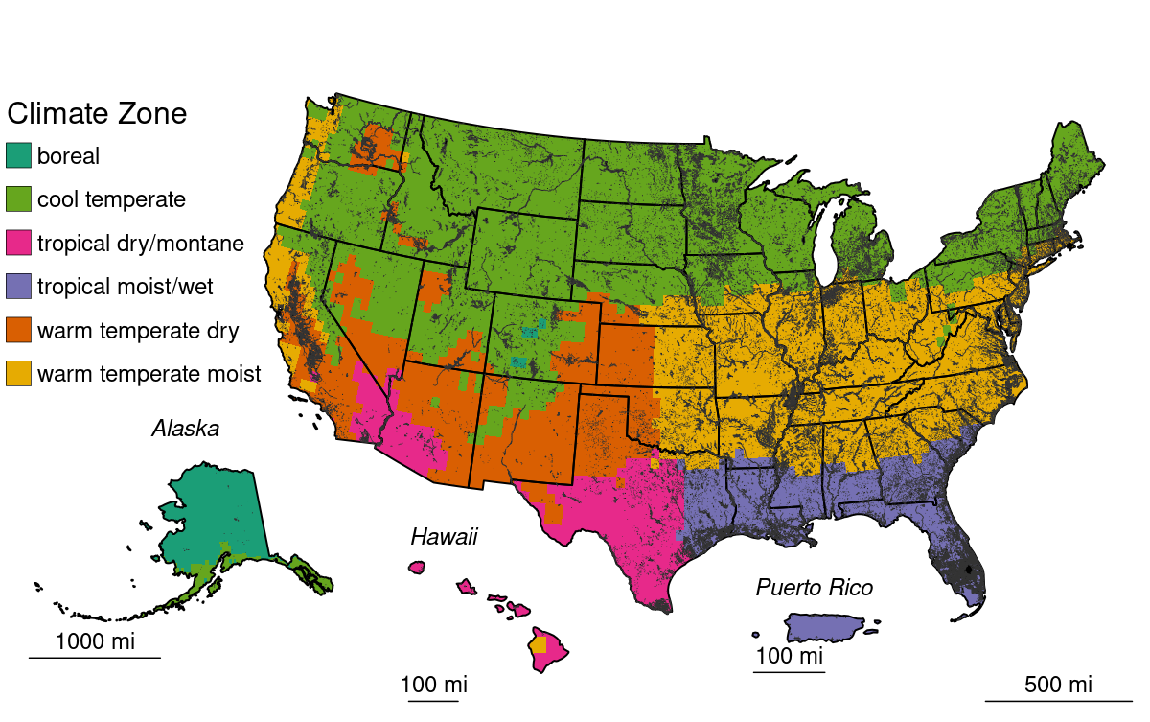

Methane is produced in reservoirs through the microbial breakdown of organic matter. Per unit area, CH4 emission rates tend to scale positively with temperature and system productivity (i.e., abundance of algae), but negatively with system size (i.e., depth, surface area). Methane produced in reservoirs can be emitted from the reservoir surface or exported from the reservoir when CH4-rich water passes through the dam. This exported CH4 can be released to the atmosphere as the water passes through hydropower turbines or the downstream river channel. Methane emitted to the atmosphere via this pathway is referred to as “downstream emissions.”

Table 6‑80 and Table 6‑81 below summarize nationally aggregated CH4 emissions from reservoirs. The increase in CH4 emissions through the time series is attributable to reservoirs matriculating from the land converted to flooded land category into the flooded land remaining flooded land category.

**Table 6‑80: CH4 Emissions from Flooded Land Remaining Flooded Land*—*Reservoirs (MMT CO2 Eq.)**

|  |  |  |  |  |  |  |  |
| --- | --- | --- | --- | --- | --- | --- | --- |
| **Source** | **1990** | **2005** | **2018** | **2019** | **2020** | **2021** | **2022** |
| **Reservoirs** |  |  |  |  |  |  |  |
| Surface Emission | 26.2 | 27.7 | 27.9 | 27.9 | 27.9 | 27.9 | 27.9 |
| Downstream Emission | 2.4 | 2.5 | 2.5 | 2.5 | 2.5 | 2.5 | 2.5 |
| **Total** | **28.6** | **30.2** | **30.4** | **30.4** | **30.4** | **30.4** | **30.4** |
| Note: Totals may not sum to due independent rounding. | | | | | | | |

**Table 6‑81: CH4 Emissions from Flooded Land Remaining Flooded Land*—*Reservoirs (kt CH4)**

|  |  |  |  |  |  |  |  |
| --- | --- | --- | --- | --- | --- | --- | --- |
| **Source** | **1990** | **2005** | **2018** | **2019** | **2020** | **2021** | **2022** |
| **Reservoirs** |  |  |  |  |  |  |  |
| Surface Emission | 937 | 989 | 997 | 997 | 997 | 997 | 997 |
| Downstream Emission | 84 | 89 | 90 | 90 | 90 | 90 | 90 |
| **Total** | **1,022** | **1,078** | **1,086** | **1,086** | **1,087** | **1,087** | **1,087** |
| Note: Totals may not sum to due independent rounding. | | | | | | | |

Methane emissions from reservoirs in Texas, Florida, and Louisiana (Figure 6‑11, Table 6‑82) compose 34 percent of national CH4 emissions from reservoirs in 2022. Emissions from these states are particularly high due to 1) the large expanse of reservoirs in these states (Table 6‑85) and 2) the high CH4 emission factor for the tropical dry/montane and topical moist climate zones which encompass a majority of the flooded land area in these states (Figure 6‑10, Table 6‑83).

Methane emissions from reservoirs in flooded land remaining flooded land increased 6.4 percent from 1990 to 2022 due to the matriculation of reservoirs in land converted to flooded land to flooded land remaining flooded land.

**Figure 6‑11: Total CH4 Emissions (Downstream + Surface) from Reservoirs in Flooded Land Remaining Flooded Land in 2022 (kt CH4)**

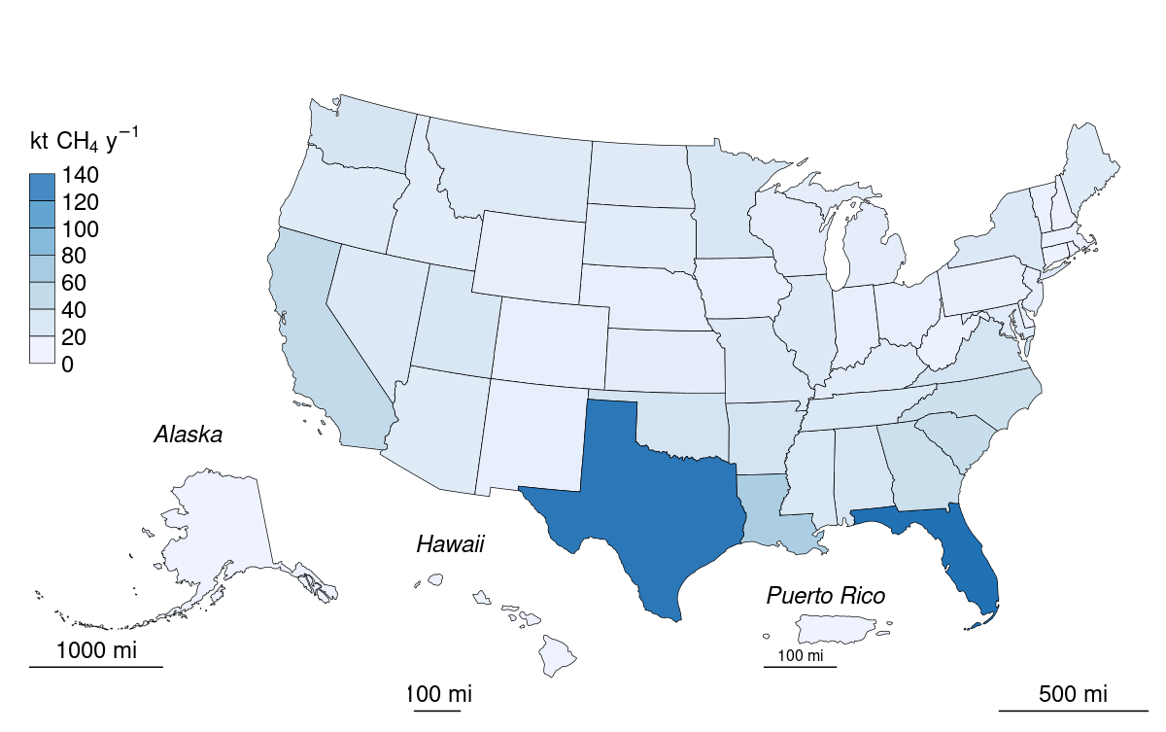

**Table 6‑82: Surface and Downstream CH4 Emissions from Reservoirs in Flooded Land Remaining Flooded Land in 2022 (kt CH4)**

|  |  |  |  |
| --- | --- | --- | --- |
| **State** | **Surface** | **Downstream** | **Total** |
| Alabama | 22 | 2 | 24 |
| Alaska | 1 | + | 1 |
| Arizona | 14 | 1 | 16 |
| Arkansas | 25 | 2 | 27 |
| California | 42 | 4 | 46 |
| Colorado | 7 | 1 | 7 |
| Connecticut | 3 | + | 3 |
| Delaware | 3 | + | 3 |
| District of Columbia | + | + | + |
| Florida | 143 | 13 | 155 |
| Georgia | 35 | 3 | 38 |
| Hawaii | 1 | + | 1 |
| Idaho | 12 | 1 | 13 |
| Illinois | 17 | 2 | 19 |
| Indiana | 7 | 1 | 7 |
| Iowa | 7 | 1 | 7 |
| Kansas | 10 | 1 | 11 |
| Kentucky | 13 | 1 | 14 |
| Louisiana | 58 | 5 | 64 |
| Maine | 14 | 1 | 15 |
| Maryland | 13 | 1 | 14 |
| Massachusetts | 5 | + | 5 |
| Michigan | 9 | 1 | 10 |
| Minnesota | 21 | 2 | 23 |
| Mississippi | 20 | 2 | 21 |
| Missouri | 17 | 1 | 18 |
| Montana | 16 | 1 | 17 |
| Nebraska | 7 | 1 | 7 |
| Nevada | 17 | 2 | 19 |
| New Hampshire | 3 | + | 4 |
| New Jersey | 9 | 1 | 9 |
| New Mexico | 7 | 1 | 7 |
| New York | 18 | 2 | 20 |
| North Carolina | 33 | 3 | 36 |
| North Dakota | 14 | 1 | 15 |
| Ohio | 7 | 1 | 7 |
| Oklahoma | 26 | 2 | 28 |
| Oregon | 14 | 1 | 16 |
| Pennsylvania | 7 | 1 | 8 |
| Puerto Rico | + | + | + |
| Rhode Island | 1 | + | 1 |
| South Carolina | 38 | 3 | 41 |
| South Dakota | 12 | 1 | 14 |
| Tennessee | 20 | 2 | 21 |
| Texas | 138 | 12 | 150 |
| Utah | 21 | 2 | 23 |
| Vermont | 5 | + | 5 |
| Virginia | 25 | 2 | 27 |
| Washington | 23 | 2 | 25 |
| West Virginia | 3 | + | 3 |
| Wisconsin | 10 | 1 | 11 |
| Wyoming | 7 | 1 | 8 |
| + Indicates values less than 0.5 kt. | | | |

**Methodology and Time-Series Consistency**

Estimates of CH4 emission for reservoirs in flooded land remaining flooded land follow the Tier 1 methodology in the *2019 Refinement to the 2006 IPCC Guidelines* (IPCC 2019). Methane emissions from the surface of these flooded lands are calculated as the product of flooded land surface area and a climate-specific emission factor (Table 6‑83). Downstream emissions are calculated as nine percent of the surface emission (Tier 1 default). Total CH4 emissions from reservoirs are calculated as the sum of surface and downstream emissions. National emissions are calculated as the sum of state emissions.

The IPCC default surface emission factors used in the Tier 1 methodology are derived from model-predicted (G-res model, Prairie et al. 2017) emission rates for all reservoirs in the Global Reservoir and Dam (GRanD) database (Lehner et al. 2011). Predicted emission rates were aggregated by the 11 IPCC climate zones (IPCC 2019, Table 7A.2) which were collapsed into six climate zones using a regression tree approach. All six aggregated climate zones are present in the United States.

**Table 6‑83: IPCC (2019) Default CH4 Emission Factors for Surface Emission from Reservoirs in Flooded Land Remaining Flooded Land**

|  |  |
| --- | --- |
| **Climate** | **Surface emission factor**  **(MT CH4 ha-1 y-1)** |
| Boreal | 0.0136 |
| Cool Temperate | 0.054 |
| Warm Temperate Dry | 0.1509 |
| Warm Temperate Moist | 0.0803 |
| Tropical Dry/Montane | 0.2837 |
| Tropical Moist/Wet | 0.1411 |
| Note: downstream CH4 emissions are calculated as 9 percent of surface emissions. Downstream emissions are not calculated for CO2. | |

*Area estimates*

U.S. reservoirs were identified from the NHDWaterbody layer in the National Hydrography Dataset Plus V2 (NHD),[1] the National Inventory of Dams (NID),[2] the National Wetlands Inventory (NWI),[3] the Navigable Waterways (NW) network,[4] and the EPA’s Safe Drinking Water Information System (SDWIS).[5] The NHD only covers the conterminous U.S., whereas the NID, NW and NWI also include Alaska, Hawaii, and Puerto Rico.

Waterbodies in the NHDWaterbody layer that were greater than or equal to 8 ha in surface area, not identified as canal/ditch in NHD, and met any of the following criteria were considered reservoirs: 1) the waterbody was classified as “Reservoir” in the NHDWaterbody layer, 2) the waterbody name in the NHDWaterbody layer included “Reservoir”, 3) the waterbody in the NHDWaterbody layer was located in close proximity (up to 100 m) to a dam in the NID, 4) the NHDWaterbody GNIS name was similar to a nearby NID feature (between 100 m to 1000 m), 5) the waterbody intersected a public drinking water intake.

EPA assumes that all features included in the NW network are subject to water-level management to maintain minimum water depths required for navigation and are therefore managed flooded lands. Navigable Waterway features greater than 8 ha in surface area are defined as reservoirs.

NWI features were considered “managed” if they had a Special Modifier value indicating the presence of management activities (Figure 6‑12). To be included in the flooded lands inventory, the managed flooded land had to be wet or saturated for at least one season per year (see “Water Regime” in Figure 6‑12). NWI features that met these criteria, were greater than 8 ha in surface area, and were not a canal/ditch (see emissions from land converted to flooded land – other constructed waterbodies) were defined as reservoirs.

Any NWI or NHD feature that intersected a drinking water intake point from SDWIS was assumed to be “managed.” The rational being that a waterbody used as a source for public drinking water is typically managed in some capacity - by flow and/or volume control.

Surface areas for identified flooded lands were taken from the NHD, NWI or NW. If features from the NHD, NWI, or NW datasets overlapped, duplicated areas were erased. The first step was to take the final NWI flooded lands features and use it to identify overlapping NHD features. If the NHD feature had its center in a NWI feature, it was removed from analysis. Next, remaining NHD features were erased from any remaining overlapping NWI features. Final selections of NHD and NWI features were used to erase any overlapping NW waterbodies.

Reservoir age was determined by assuming the waterbody was created the same year as a nearby (up to 100 m) NID feature. If no nearby NID feature was identified, it was assumed the waterbody was greater than 20-years old throughout the time series.

**Figure 6‑12: Selected Features from NWI that Meet Flooded Lands Criteria**

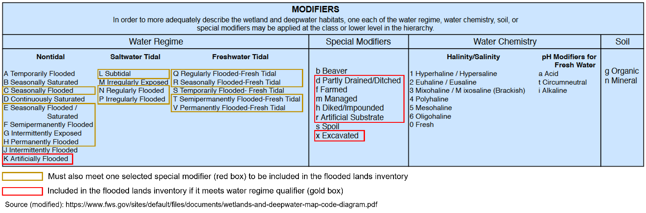

IPCC (2019) allows for the exclusion of managed waterbodies from the inventory if the water surface area or residence time was not substantially changed by the construction of the dam. The guidance does not quantify what constitutes a “substantial” change, but here EPA excludes the U.S. Great Lakes from the inventory based on expert judgment that neither the surface area nor water residence time was substantially altered by their associated dams.

Reservoirs were disaggregated by state (using boundaries from the 2016 U.S. Census Bureau[6]) and climate zone. Downstream and surface emissions for cross-state reservoirs were allocated to states based on the surface area that the reservoir occupied in each state. Only the U.S. portion of reservoirs that cross country borders were included in the inventory.

The surface area of reservoirs in flooded land remaining flooded land increased by approximately 6 percent from 1990 to 2022 (Table 6‑84) due to reservoirs matriculating into flooded land remaining flooded land when they reached 20 years of age.

**Table 6‑84: National Totals of Reservoir Surface Area in Flooded Land Remaining Flooded Land (millions of ha)**

|  |  |  |  |  |  |  |  |
| --- | --- | --- | --- | --- | --- | --- | --- |
| **Surface Area (millions of ha)** | **1990** | **2005** | **2018** | **2019** | **2020** | **2021** | **2022** |
| Reservoir | 9.6 | 10.1 | 10.2 | 10.2 | 10.2 | 10.2 | 10.2 |

**Table 6‑85: State Breakdown of Reservoir Surface Area in Flooded Land Remaining Flooded Land (millions of ha)**

|  |  |  |  |  |  |  |  |
| --- | --- | --- | --- | --- | --- | --- | --- |
| **State** | **1990** | **2005** | **2018** | **2019** | **2020** | **2021** | **2022** |
| Alabama | 0.22 | 0.23 | 0.23 | 0.23 | 0.23 | 0.23 | 0.23 |
| Alaska | 0.02 | 0.02 | 0.02 | 0.02 | 0.02 | 0.02 | 0.02 |
| Arizona | 0.06 | 0.06 | 0.06 | 0.06 | 0.06 | 0.06 | 0.06 |
| Arkansas | 0.28 | 0.29 | 0.29 | 0.29 | 0.29 | 0.29 | 0.29 |
| California | 0.37 | 0.39 | 0.39 | 0.39 | 0.39 | 0.39 | 0.39 |
| Colorado | 0.08 | 0.09 | 0.09 | 0.09 | 0.09 | 0.09 | 0.09 |
| Connecticut | 0.03 | 0.03 | 0.04 | 0.04 | 0.04 | 0.04 | 0.04 |
| Delaware | 0.03 | 0.03 | 0.03 | 0.03 | 0.03 | 0.03 | 0.03 |
| District of Columbia | + | + | + | + | + | + | + |
| Florida | 0.98 | 1.01 | 1.01 | 1.01 | 1.01 | 1.01 | 1.01 |
| Georgia | 0.27 | 0.29 | 0.29 | 0.29 | 0.29 | 0.29 | 0.29 |
| Hawaii | + | + | + | + | + | + | + |
| Idaho | 0.17 | 0.19 | 0.19 | 0.19 | 0.19 | 0.19 | 0.19 |
| Illinois | 0.17 | 0.18 | 0.22 | 0.22 | 0.22 | 0.22 | 0.22 |
| Indiana | 0.07 | 0.08 | 0.08 | 0.08 | 0.08 | 0.08 | 0.08 |
| Iowa | 0.08 | 0.09 | 0.10 | 0.10 | 0.10 | 0.10 | 0.10 |
| Kansas | 0.09 | 0.11 | 0.11 | 0.11 | 0.11 | 0.11 | 0.11 |
| Kentucky | 0.16 | 0.16 | 0.16 | 0.16 | 0.16 | 0.16 | 0.16 |
| Louisiana | 0.40 | 0.41 | 0.41 | 0.41 | 0.41 | 0.41 | 0.41 |
| Maine | 0.25 | 0.26 | 0.26 | 0.26 | 0.26 | 0.26 | 0.26 |
| Maryland | 0.16 | 0.16 | 0.16 | 0.16 | 0.16 | 0.16 | 0.16 |
| Massachusetts | 0.07 | 0.07 | 0.07 | 0.07 | 0.07 | 0.07 | 0.07 |
| Michigan | 0.16 | 0.17 | 0.17 | 0.17 | 0.17 | 0.17 | 0.17 |
| Minnesota | 0.38 | 0.38 | 0.39 | 0.39 | 0.39 | 0.39 | 0.39 |
| Mississippi | 0.18 | 0.19 | 0.19 | 0.19 | 0.19 | 0.19 | 0.19 |
| Missouri | 0.19 | 0.21 | 0.21 | 0.21 | 0.21 | 0.21 | 0.21 |
| Montana | 0.27 | 0.29 | 0.29 | 0.29 | 0.29 | 0.29 | 0.29 |
| Nebraska | 0.07 | 0.08 | 0.08 | 0.08 | 0.08 | 0.08 | 0.08 |
| Nevada | 0.09 | 0.09 | 0.09 | 0.09 | 0.09 | 0.09 | 0.09 |
| New Hampshire | 0.06 | 0.06 | 0.06 | 0.06 | 0.06 | 0.06 | 0.06 |
| New Jersey | 0.11 | 0.11 | 0.11 | 0.11 | 0.11 | 0.11 | 0.11 |
| New Mexico | 0.05 | 0.05 | 0.05 | 0.05 | 0.05 | 0.05 | 0.05 |
| New York | 0.31 | 0.32 | 0.32 | 0.32 | 0.32 | 0.32 | 0.32 |
| North Carolina | 0.39 | 0.41 | 0.41 | 0.41 | 0.41 | 0.41 | 0.41 |
| North Dakota | 0.10 | 0.25 | 0.26 | 0.26 | 0.26 | 0.26 | 0.26 |
| Ohio | 0.08 | 0.09 | 0.09 | 0.09 | 0.09 | 0.09 | 0.09 |
| Oklahoma | 0.24 | 0.27 | 0.27 | 0.27 | 0.27 | 0.27 | 0.27 |
| Oregon | 0.20 | 0.20 | 0.20 | 0.20 | 0.20 | 0.20 | 0.20 |
| Pennsylvania | 0.09 | 0.11 | 0.11 | 0.11 | 0.11 | 0.11 | 0.11 |
| Puerto Rico | + | + | + | + | + | + | + |
| Rhode Island | 0.02 | 0.02 | 0.02 | 0.02 | 0.02 | 0.02 | 0.02 |
| South Carolina | 0.31 | 0.32 | 0.33 | 0.33 | 0.33 | 0.33 | 0.33 |
| South Dakota | 0.23 | 0.23 | 0.23 | 0.23 | 0.23 | 0.23 | 0.23 |
| Tennessee | 0.18 | 0.24 | 0.24 | 0.24 | 0.24 | 0.24 | 0.24 |
| Texas | 0.63 | 0.70 | 0.71 | 0.71 | 0.71 | 0.71 | 0.71 |
| Utah | 0.18 | 0.18 | 0.18 | 0.18 | 0.18 | 0.18 | 0.18 |
| Vermont | 0.09 | 0.09 | 0.09 | 0.09 | 0.09 | 0.09 | 0.09 |
| Virginia | 0.30 | 0.31 | 0.31 | 0.31 | 0.31 | 0.31 | 0.31 |
| Washington | 0.24 | 0.24 | 0.24 | 0.24 | 0.24 | 0.24 | 0.24 |
| West Virginia | 0.03 | 0.03 | 0.04 | 0.04 | 0.04 | 0.04 | 0.04 |
| Wisconsin | 0.18 | 0.18 | 0.18 | 0.18 | 0.18 | 0.18 | 0.18 |
| Wyoming | 0.12 | 0.13 | 0.14 | 0.14 | 0.14 | 0.14 | 0.14 |
| **Total** | **9.47** | **10.10** | **10.20** | **10.20** | **10.20** | **10.20** | **10.20** |
| + Indicates values less than 0.005 million ha.  Note: Totals may not sum due to independent rounding. | | | | | | | |

**Uncertainty**

Uncertainty in estimates of CH4 emissions from reservoirs in flooded land remaining flooded land (Table 6‑86) are developed using Monte Carlo simulations (IPCC Approach 2) and include uncertainty in the default emission factors and land areas. Each iteration of the simulation draws surface and downstream emission factors from a statistical distribution based on the mean and variance in the *2019 Refinement to the 2006 IPCC Guidelines* (IPCC 2019). The CH4 emission factors for surface and downstream emissions are modeled using normal and lognormal distributions, respectively. The 2019 IPCC Refinement does not contain sufficient information to define a normal distribution for the CO2 emission factor and a uniform distribution bounded by the 95% confidence internal of the mean is assumed. Uncertainties in the spatial data include 1) uncertainty in area estimates from the NHD, NWI, and NW, and 2) uncertainty in the location of dams in the NID and drinking water intakes in SDWIS. Overall uncertainties in these spatial datasets are unknown, but uncertainty for remote sensing products is assumed to be ± 10 - 15 percent based on IPCC guidance (IPCC 2003). An uncertainty range of ± 15 percent for the reservoir area estimates is assumed and is based on expert judgment. Each iteration of the simulation draws a surface area for each waterbody from a uniform distribution bounded by ± 15 percent of the estimated surface area.

**Table 6‑86: Approach 2 Quantitative Uncertainty Estimates for CH4 Emissions from Reservoirs in Flooded Land Remaining Flooded Land**

|  |  |  |  |  |  |  |  |
| --- | --- | --- | --- | --- | --- | --- | --- |
| **Source** | **Gas** | **2022 Emission Estimate** | **Uncertainty Range Relative to Emission Estimatea** | | | | |
| **(MMT CO2 Eq.)** | **(MMT CO2 Eq.)** | | | **(%)** | |
|  |  |  | **Lower Bound** | **Upper Bound** | **Lower Bound** | | **Upper Bound** |
| **Reservoir** |  |  |  |  |  | |  |
| Surface | CH4 | 27.9 | 27.4 | 28.4 | -1.7% | | +1.7% |
| Downstream | CH4 | 2.5 | 2.4 | 3.1 | -5.6% | | +22.4% |
| **Total** | **CH4** | **30.4** | **29.9** | **31.3** | **-1.6%** | | **+2.9%** |
| a Range of emission estimates predicted by Monte Carlo stochastic simulation for a 95 percent confidence interval. | | | | | | | |

**QA/QC and Verification**

The National Hydrography Data (NHD) is managed by the USGS in collaboration with many other federal, state, and local entities. Extensive QA/QC procedures are incorporated into the curation of the NHD. The National Inventory of Dams (NID) is maintained by the U.S. Army Corps of Engineers (USACE) in collaboration with the Federal Emergency Management Agency (FEMA) and state regulatory offices. USACE resolves duplicative and conflicting data from 68 data sources, which helps obtain the more complete, accurate, and updated NID. The Navigable Waterways (NW) dataset is part of the U.S. Department of Transportation (USDOT)/Bureau of Transportation Statistics (BTS) National Transportation Atlas Database (NTAD). The NW is a comprehensive network database of the nation's navigable waterways updated on a continuing basis. U.S. Fish and Wildlife Service is the principal agency in charge of wetland mapping including the National Wetlands Inventory (NWI). Quality and consistency of the Wetlands Layer is supported by federal wetlands mapping and classification [standards](https://www.fws.gov/program/national-wetlands-inventory/data-standards), which were developed under the oversight of the Federal Geographic Data Committee (FGDC) with input by the [FGDC Wetlands Subcommittee](https://www.fgdc.gov/organization/working-groups-subcommittees/wsc/index_html). This dataset is part of the FGDC [Water-Inland Theme](https://www.geoplatform.gov/ngda/waterinland), which is co-chaired by the FWS and the U.S. Geological Survey. The EPA's Safe Drinking Water Information System (SDWIS) tracks information on drinking water contamination levels as required by the 1974 Safe Drinking Water Act and its 1986 and 1996 amendments.

General QA/QC procedures were applied to activity data, documentation, and emission calculations consistent with the U.S. Inventory QA/QC plan, which is in accordance with Vol. 1 Chapter 6 of the *2006* *IPCC* *Guidelines* (see Annex 8 for more details). All calculations were executed independently in Excel and R. Ten percent of state and national totals were randomly selected for comparison between the two approaches to ensure there were no computational errors.

**Recalculations Discussion**

The EPA's SDWIS is a new data source used in the current (1990 through 2022) *Inventory*. The assumption is that any waterbody used as a public drinking water source is managed in some capacity - by flow and/or volume control. This data source added 418 reservoirs totaling 736,344 ha.

The National Inventory of Dams (NID) data are updated regularly. The version of NID used for the current *Inventory* contains 47 new dams and updated values for “year of dam completion” for 975 dams relative to the previous (1990 through 2021) *Inventory* data. Similarly, the National Wetlands Inventory (NWI) is periodically updated. The NWI version used for the current *Inventory* has major updates for MS, ND, NM, and MT.

The net effect of these recalculations was an average annual increase in CH4 emission estimates from reservoirs of 1.23 MMT CO2 Eq., or 4 percent, over the time series from 1990 to 2021 compared to the previous *Inventory*.

**Planned Improvements**

The EPA recently completed a survey of greenhouse gas emissions from 108 reservoirs in the conterminous United States.[7] The data will be used to develop country-specific emission factors for U.S. reservoirs to be used in the 1990 through 2024 *Inventory* submission.

**Emissions from Flooded Land Remaining Flooded Land–Other Constructed Waterbodies**

The IPCC (IPCC 2019) provides emission factors for several types of “other constructed waterbodies” including freshwater ponds and canals/ditches. IPCC (2019) describes ponds as waterbodies that are “…constructed by excavation and/or construction of walls to hold water in the landscape for a range of uses, including agricultural water storage, access to water for livestock, recreation, and aquaculture.” Furthermore, the IPCC “Decision tree for types of Flooded Land” (IPCC 2019, Fig. 7.2) defines a size threshold of 8 ha to distinguish reservoirs from “other constructed waterbodies.” For this *Inventory*, ponds are defined as managed flooded land that are 1) less than 8 ha in surface area, and 2) not categorized as canals/ditches. IPCC (2019) further distinguishes saline versus brackish ponds, with the former supporting lower CH4 emissions than the latter. Activity data on pond salinity are not uniformly available for the conterminous United States and all ponds in the inventory are assumed to be freshwater. Ponds often receive high organic matter and nutrient loadings, may have low oxygen levels, and are often sites of substantial CH4 emissions from anaerobic sediments.

Canals and ditches (terms are used interchangeably) are linear water features constructed to transport water (i.e., stormwater drainage, aqueduct), to irrigate or drain land, to connect two or more bodies of water, or to serve as a waterway for watercraft. The geometry and construction of canals and ditches varies widely and includes narrow earthen channels (<1 m wide) and concrete lined aqueducts in excess of 50 m wide. Canals and ditches can be extensive in many agricultural, forest and settlement areas, and may also be significant sources of emissions in some circumstances.

Methane emissions from freshwater ponds in flooded land remaining flooded land increased by approximately 1 percent from 1990 to 2022. Methane emissions from canals and ditches have remained constant throughout the time series because age data are not available for canals and ditches, thus they are assumed to be greater than 20-years old in 1990 and are included in flooded land remaining flooded land throughout the time series. Overall, CH4 emissions from other constructed waterbodies have remained fairly constant since 1990 (Table 6‑87 and Table 6‑88).

**Table 6‑87: CH4 Emissions from Other Constructed Waterbodies in Flooded Land Remaining Flooded Land (MMT CO2 Eq.)**

|  |  |  |  |  |  |  |  |
| --- | --- | --- | --- | --- | --- | --- | --- |
| **Source** | **1990** | **2005** | **2018** | **2019** | **2020** | **2021** | **2022** |
| **Other Constructed Waterbodies** |  |  |  |  |  |  |  |
| Canals and Ditches | 2.3 | 2.3 | 2.3 | 2.3 | 2.3 | 2.3 | 2.3 |
| Freshwater Ponds | 11.4 | 11.5 | 11.5 | 11.5 | 11.5 | 11.5 | 11.5 |
| **Total** | **13.7** | **13.8** | **13.8** | **13.8** | **13.8** | **13.8** | **13.8** |
| Note: Totals may not sum due to independent rounding. | | | | | | | |

**Table 6‑88: CH4 Emissions from Other Constructed Waterbodies in Flooded Land Remaining Flooded Land (kt CH4)**

|  |  |  |  |  |  |  |  |
| --- | --- | --- | --- | --- | --- | --- | --- |
| **Source** | **1990** | **2005** | **2018** | **2019** | **2020** | **2021** | **2022** |
| **Other Constructed Waterbodies** |  |  |  |  |  |  |  |
| Canals and Ditches | 80.9 | 80.9 | 80.9 | 80.9 | 80.9 | 80.9 | 80.9 |
| Freshwater Ponds | 406.6 | 411.0 | 411.7 | 411.8 | 411.8 | 411.8 | 411.9 |
| **Total** | **487.5** | **491.9** | **492.6** | **492.6** | **492.7** | **492.7** | **492.7** |
| Note: Totals may not sum due to independent rounding. | | | | | | | |

Florida and Louisiana have the greatest methane emissions from canals and ditches in the United States (Figure 6‑13, Table 6‑89). Presumably, most of these canals serve to drain the extensive wetland complexes in these states (Davis, 1973). California has the third greatest methane emissions from canals and ditches. Canals and ditches in California primarily serve to convey water from the mountains to urban and agricultural areas. Michigan and Minnesota have the fourth and fifth largest methane emissions from canals and ditches. These systems serve to drain historic wetlands to facilitate row-crop agriculture. Texas, Florida, and Georgia have the greatest methane emissions from freshwater ponds, although states throughout the eastern United States make significant contributions to the national total. These patterns of emissions are in accordance with the distribution of other constructed waterbodies in the United States.

**Table 6‑89: CH4 Emissions from Other Constructed Waterbodies in Flooded Land Remaining Flooded Land in 2022 (kt CH4)**

|  |  |  |  |
| --- | --- | --- | --- |
| **State** | **Canals and Ditches** | **Freshwater Ponds** | **Total** |
| Alabama | + | 10.5 | 10.6 |
| Alaska | + | + | + |
| Arizona | 1.5 | 1.0 | 2.4 |
| Arkansas | 3.1 | 9.4 | 12.4 |
| California | 7.0 | 9.2 | 16.2 |
| Colorado | 2.9 | 4.8 | 7.7 |
| Connecticut | + | 1.8 | 1.8 |
| Delaware | + | 0.9 | 0.9 |
| District of Columbia | + | + | + |
| Florida | 15.6 | 30.7 | 46.2 |
| Georgia | + | 21.0 | 21.2 |
| Hawaii | + | + | 0.5 |
| Idaho | 1.7 | 2.4 | 4.1 |
| Illinois | 1.0 | 11.7 | 12.8 |
| Indiana | 1.7 | 10.6 | 12.3 |
| Iowa | + | 11.2 | 11.6 |
| Kansas | + | 15.4 | 15.5 |
| Kentucky | + | 7.7 | 7.9 |
| Louisiana | 9.4 | 5.9 | 15.3 |
| Maine | + | 3.5 | 3.5 |
| Maryland | + | 2.3 | 2.7 |
| Massachusetts | + | 2.3 | 2.3 |
| Michigan | 5.4 | 10.0 | 15.4 |
| Minnesota | 4.7 | 12.7 | 17.3 |
| Mississippi | 1.6 | 13.4 | 15.1 |
| Missouri | 2.4 | 20.7 | 23.1 |
| Montana | 2.0 | 10.5 | 12.5 |
| Nebraska | 2.0 | 9.1 | 11.1 |
| Nevada | 0.7 | 0.8 | 1.5 |
| New Hampshire | + | 1.0 | 1.1 |
| New Jersey | + | 3.0 | 3.4 |
| New Mexico | 0.8 | 2.1 | 2.9 |
| New York | + | 8.3 | 8.7 |
| North Carolina | 2.6 | 12.2 | 14.8 |
| North Dakota | 0.8 | 20.6 | 21.3 |
| Ohio | 0.8 | 8.9 | 9.7 |
| Oklahoma | + | 19.3 | 19.4 |
| Oregon | 1.0 | 3.6 | 4.6 |
| Pennsylvania | + | 4.1 | 4.1 |
| Puerto Rico | + | + | + |
| Rhode Island | + | + | + |
| South Carolina | 1.3 | 10.4 | 11.7 |
| South Dakota | + | 16.6 | 16.9 |
| Tennessee | + | 6.7 | 6.8 |
| Texas | 4.6 | 32.1 | 36.8 |
| Utah | 0.8 | 2.0 | 2.8 |
| Vermont | + | 0.8 | 0.8 |
| Virginia | 0.5 | 7.3 | 7.9 |
| Washington | + | 2.0 | 2.5 |
| West Virginia | + | 1.5 | 1.5 |
| Wisconsin | + | 3.8 | 4.2 |
| Wyoming | 0.9 | 4.8 | 5.7 |
| **Total** | **80.9** | **411.9** | **492.7** |
| + Indicates values less than 0.5 kt.  Note: Totals may not sum due to independent rounding. | | | |

* **Figure 6‑13: 2022 CH4 Emissions from A) Ditches and Canals and B) Freshwater Ponds in Flooded Land Remaining Flooded Land (kt CH4)**

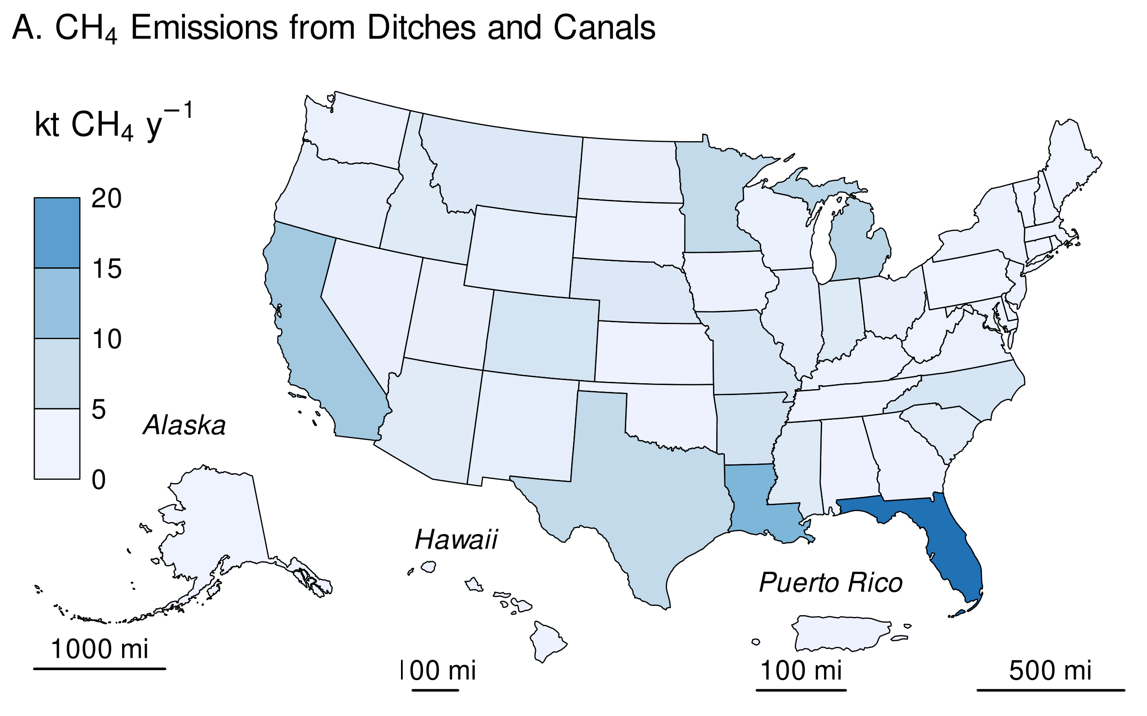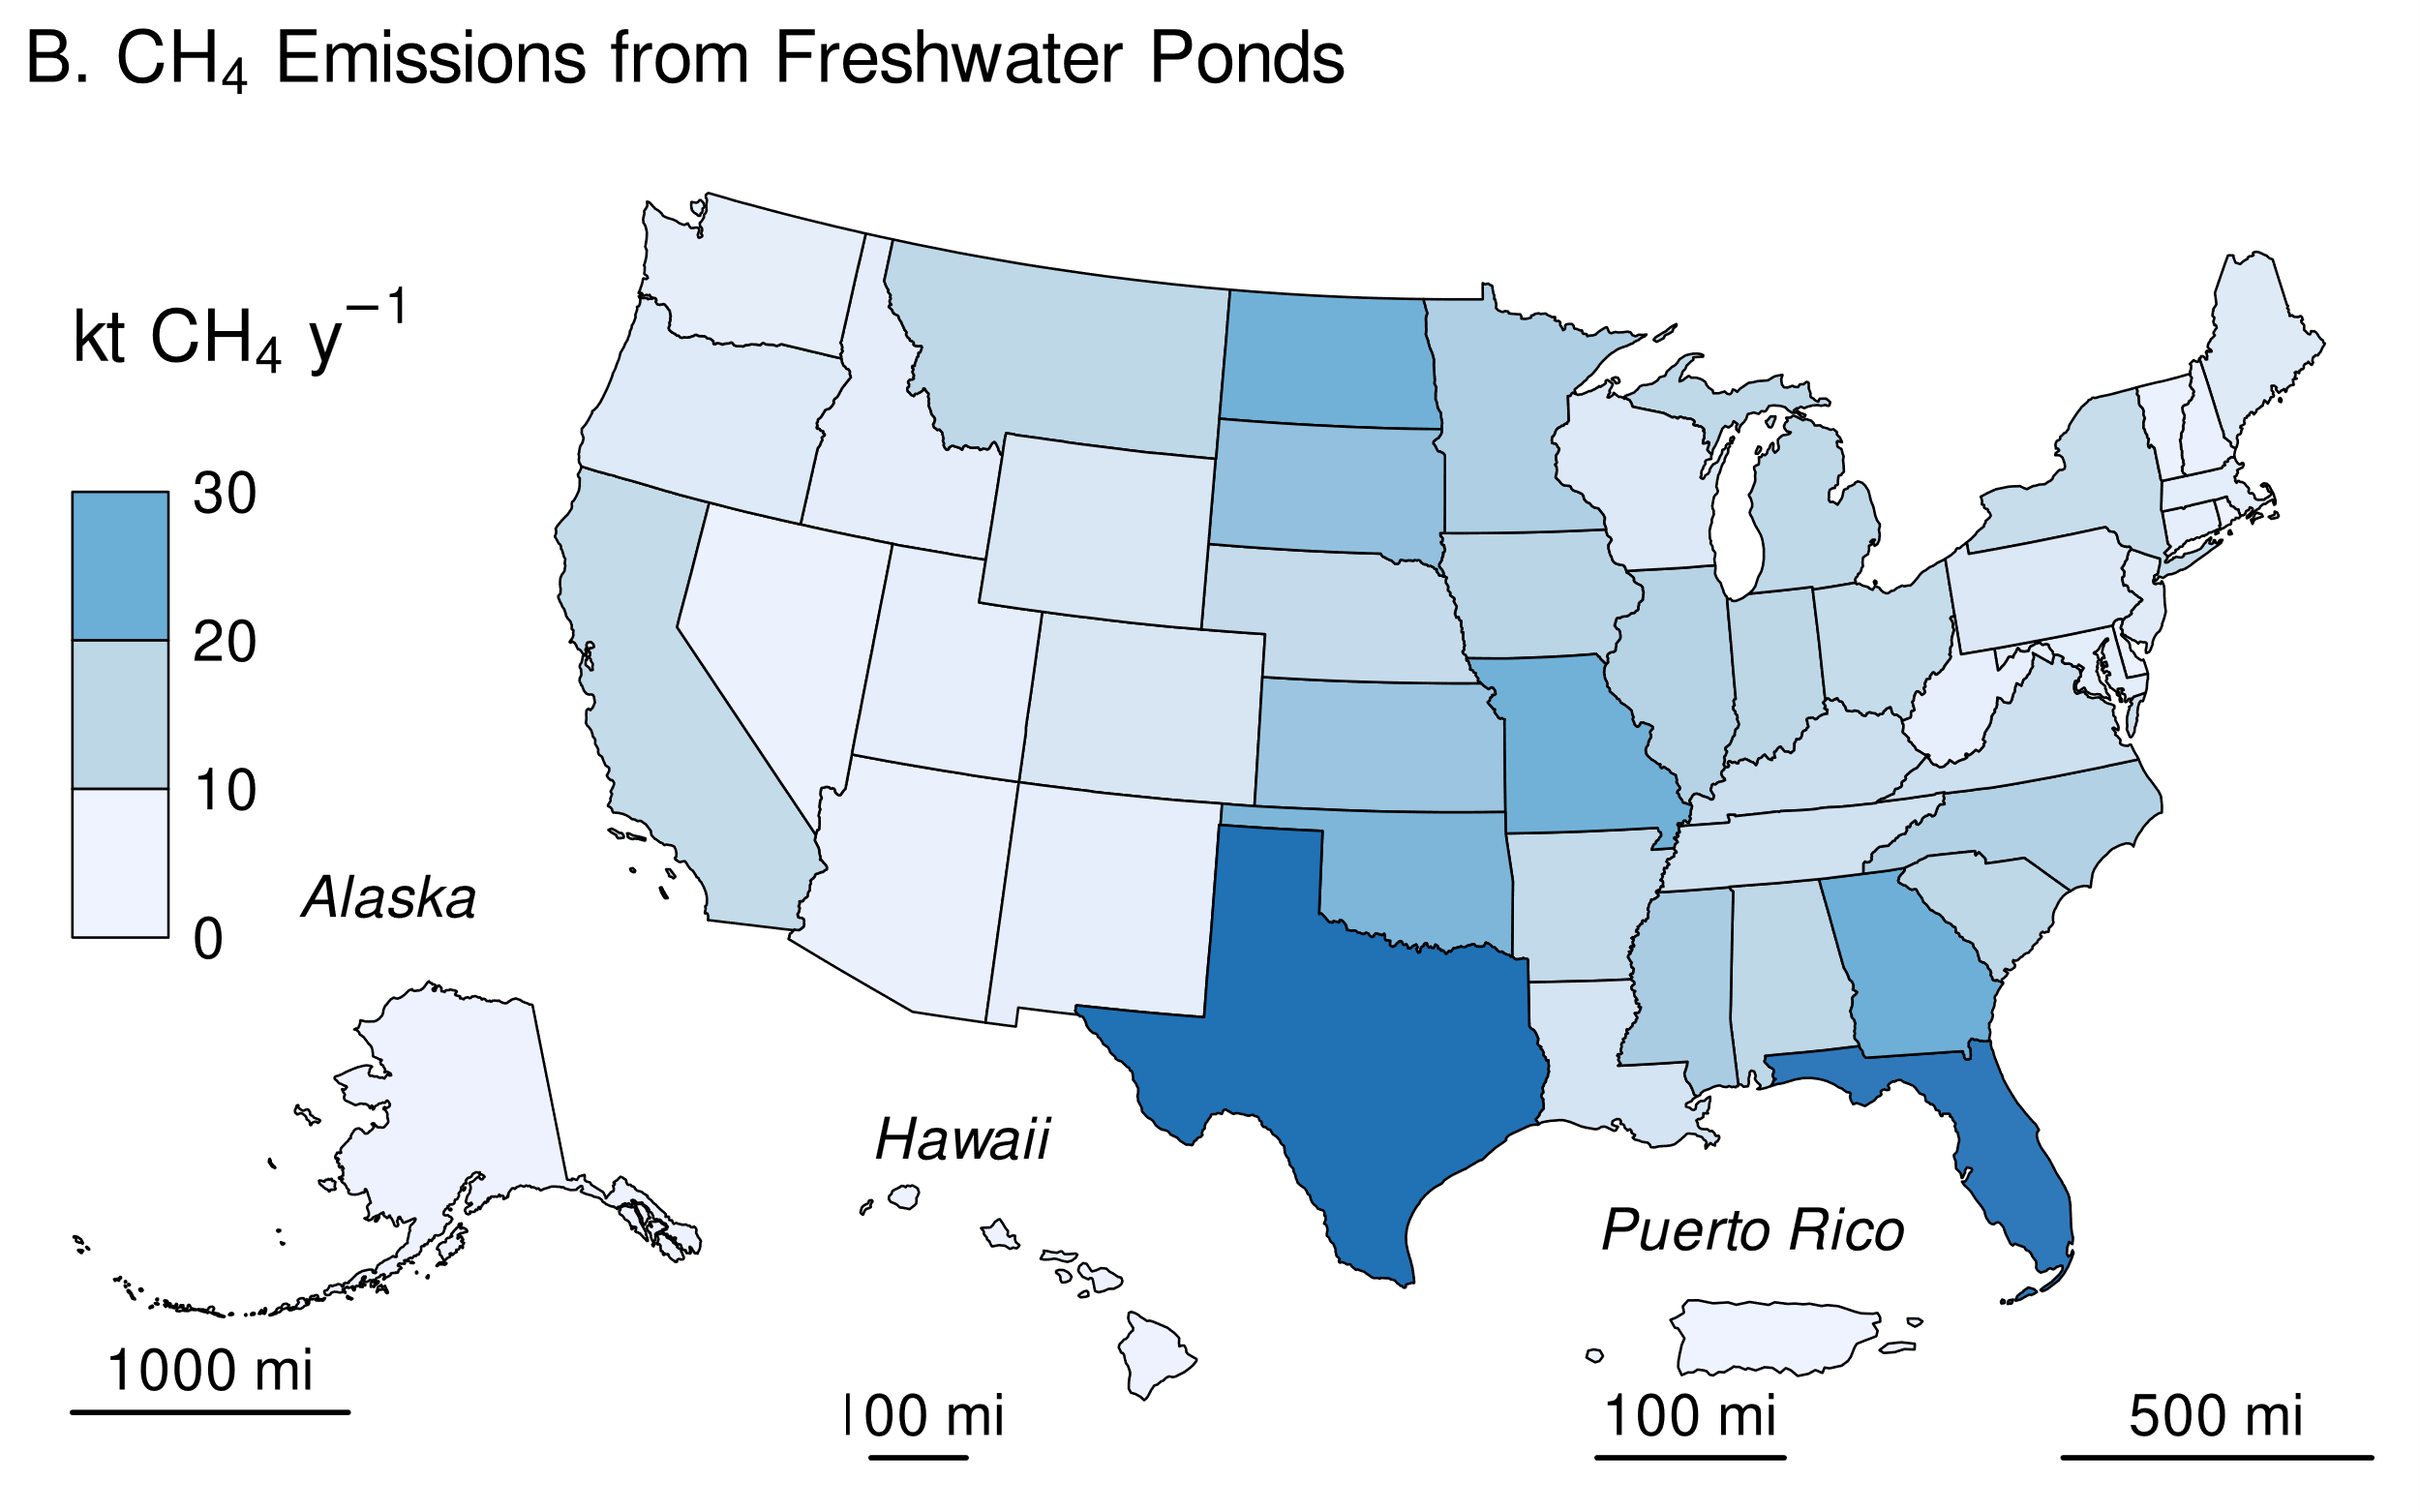

**Methodology and Time-Series Consistency**

Estimates of CH4 emissions for other constructed waterbodies in flooded land remaining flooded Land follow the Tier 1 methodology in IPCC (2019). All calculations are performed at the state level and summed to obtain national estimates. Based on IPCC guidance, methane emissions from the surface of these flooded lands are calculated as the product of flooded land surface area and an emission factor (Table 6‑90). Although literature data on greenhouse gas emissions from canals and ditches is relatively sparse, they have the highest default emission factor of all flooded land types (Table 6‑90). Default emission factors for freshwater ponds are on the higher end of those for reservoirs. There are insufficient data to support climate-specific emission factors for ponds or canals and ditches. Downstream emissions are not inventoried for other constructed waterbodies because 1) many of these systems are not associated with dams (e.g., excavated ponds and ditches), and 2) there are insufficient data to derive downstream emission factors for other constructed waterbodies that are associated with dams (IPCC 2019).

**Table 6‑90: IPCC (2019) Default CH4 Emission Factors for Surface Emissions from Other Constructed Waterbodies in Flooded Land Remaining Flooded Land**

|  |  |
| --- | --- |
| **Other Constructed Waterbody** | **Surface emission factor**  **(MT CH4 ha-1 y-1)** |
| Freshwater ponds | 0.183 |
| Canals and ditches | 0.416 |

*Area estimates*

Other constructed waterbodies were identified from the NHDWaterbody layer in the National Hydrography Dataset Plus V2 (NHD),[8] the National Inventory of Dams (NID),[9] the National Wetlands Inventory (NWI),[10] the Navigable Waterways (NW) network,[11] and the EPA’s Safe Drinking Water Information System (SDWIS).[12] The NHD only covers the conterminous United States, whereas the NID, NW and NWI also include Alaska, Hawaii, District of Columbia, and Puerto Rico. The following paragraphs present the criteria used to identify other constructed waterbodies in the NHD, NW, and NWI.

Waterbodies in the NHDWaterbody layer that were greater than 20-years old, less than 8 ha in surface area, not identified as canal/ditch in NHD, and met any of the following criteria were considered freshwater ponds in flooded land remaining flooded land: 1) the waterbody was classified “Reservoir” in the NHDWaterbody layer, 2) the waterbody name in the NHDWaterbody layer included “Reservoir”, 3) the waterbody in the NHDWaterbody layer was located in close proximity (up to 100 m) to a dam in the NID, 4) the NHDWaterbody GNIS name was similar to nearby NID feature (between 100 m to 1000 m), the waterbody intersected a drinking water intake.

EPA assumes that all features included in the NW are subject to water-level management to maintain minimum water depths required for navigation and are therefore managed flooded lands. NW features that were less than 8 ha in surface area and not identified as canals/ditch (see below) were considered freshwater ponds. Only 2.1 percent of NW features met these criteria, and they were primarily associated with larger navigable waterways, such as lock chambers on impounded rivers.

NWI features were considered “managed” if they had a special modifier value indicating the presence of management activities (Figure 6‑12). To be included in the flooded lands inventory, the managed flooded land had to be wet or saturated for at least one season per year (see “Water Regime” in Figure 6‑12). NWI features that met these criteria, were less than 8 ha in surface area, and were not a canal/ditch (see below) were defined as freshwater ponds.

Any NWI or NHD feature that intersected a drinking water intake point from SDWIS was assumed to be “managed.” The rational being that a waterbody used as a source for public drinking water is typically managed in some capacity - by flow and/or volume control.

Canals and ditches, a subset of other constructed waterbodies, were identified in the NWI by their morphology. Unlike a natural water body, canals and ditches are typically narrow, linear features with abrupt angular turns. Figure 6‑14 contrasts the unique shape of ditches/canals vs more natural water features.

* **Figure 6‑14: Left: NWI Features Identified as Canals/Ditches (pink) by Unique Narrow, Linear/Angular Morphology. Right: Non-Canal/Ditches with More Natural Morphology (blue)**

This morphology was identified systematically using shape attributes in a decision tree model. A training set of 752 features were identified as either “ditch” or “not ditch” using expert judgment. The training set was used to train a decision tree which was used to categorize millions of NWI features based on three shape attribute ratios (Figure 6‑12).

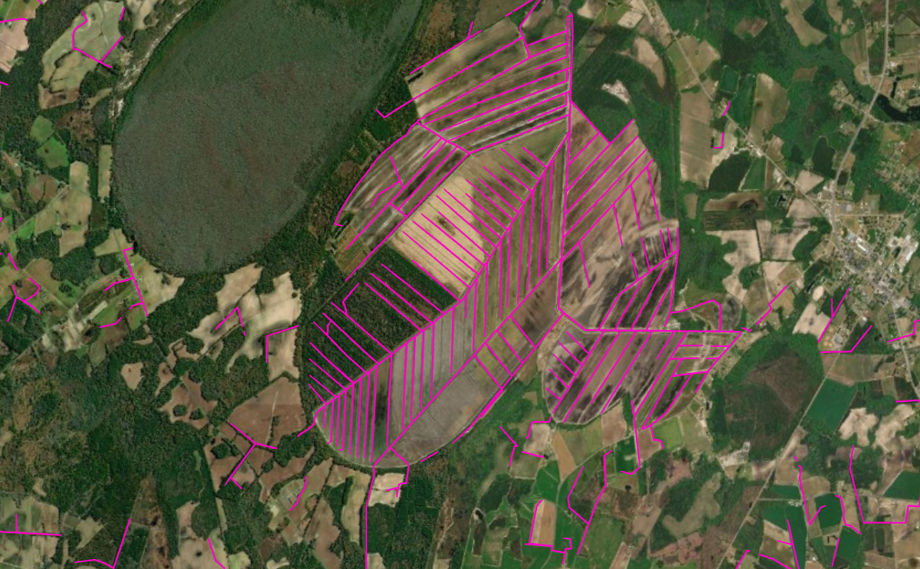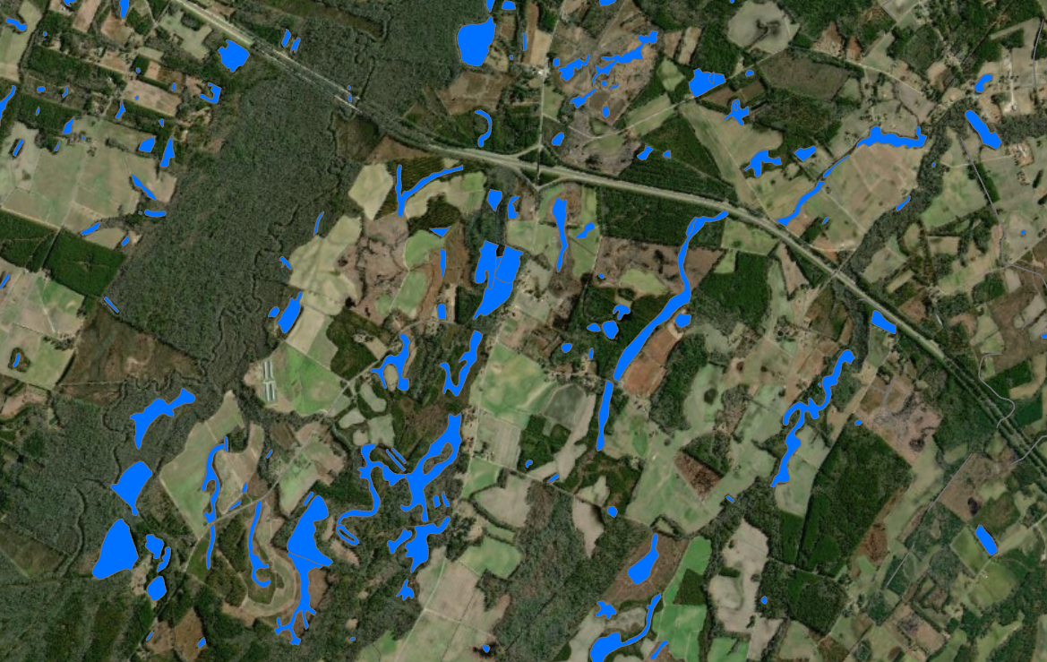

**Table 6‑91: Predictors used in Decision Tree to Identify Canal/Ditches**

|  |
| --- |
| Shape Length : # of Shape Vertices |
| Shape Area : Shape Length |
| Shape Area : # of Shape Vertices |

The decision tree built a model using 80 percent of the 752 training features and used the 20 percent to validate the model. The model was 93.1 percent accurate. Below are the validation results (Table 6‑92).

**Table 6‑92: Validation Results for Ditch/Canal Classification Decision Tree**

|  |  |  |
| --- | --- | --- |
| **Prediction** | **Truth** | |
| Ditch/Canal | Not Ditch/Canal |
| Ditch/Canal | 49 | 5 |
| Not Ditch/Canal | 8 | 27 |

The decision tree model was then applied to the entire NWI dataset using the following shape attribute ratios (Figure 6‑15).

**Figure 6‑15: Structure of Decision Tree Used to Identify Canals/Ditches**

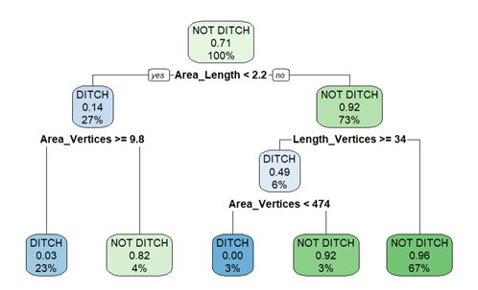

Surface areas for other constructed waterbodies were taken from NHD, NWI or the NW. If features from the NHD, NWI, or the NW datasets overlapped, these areas were erased. The first step was to take the final NWI flooded lands features and use it to identify overlapping NHD features. If the NHD feature had its center in a NWI feature, it was removed from analysis. Next, remaining NHD features were erased from any remaining overlapping NWI features. Final selections of NHD and NWI features were used to erase any overlapping NW waterbodies.

The age of other constructed waterbody features was determined by assuming the waterbody was created the same year as a nearby (up to 100 m) NID feature. If no nearby NID feature was identified, it was assumed the waterbody was greater than 20-years old throughout the time series. No canal/ditch features were associated with a nearby dam, therefore all canal/ditch features were assumed to be greater than 20-years old through the time series.

For the year 2022, this *Inventory* contains 2,250,662 ha of freshwater ponds and 194,412 ha of canals and ditches in flooded land remaining flooded land (Table 6‑93). The surface area of freshwater ponds increased by 28,632 ha (1.3 percent) from 1990 to 2022 due to flooded lands matriculating from land converted to flooded land to flooded land remaining flooded land. All canals and ditches were assumed to be greater than 20-years old throughout the time series, thus the surface area of these flooded lands is constant throughout the time series.

**Table 6‑93: National Surface Area Totals in Flooded Land Remaining Flooded Land - Other Constructed Waterbodies (ha)**

|  |  |  |  |  |  |  |  |  |
| --- | --- | --- | --- | --- | --- | --- | --- | --- |
|  | **1990** | **2005** | **2018** | **2019** | **2020** | **2021** | **2022** | |
| Canals and ditches | 194,412 | 194,412 | 194,412 | 194,412 | 194,412 | 194,412 | 194,412 | |
| Freshwater ponds | 2,222,030 | 2,245,881 | 2,249,672 | 2,250,007 | 2,250,337 | 2,250,540 | 2,250,662 | |
| **Total** | **2,416,442** | **2,440,292** | **2,444,084** | **2,444,418** | **2,444,749** | **2,444,951** | **2,445,074** | |
| Note: Totals may not sum due to independent rounding. | | | | | | | |

Canals and ditches in the conterminous United States are most abundant in the Gulf Coast states and California (Figure 6‑16A, Table ). Florida contains 19 percent of all U.S. canal and ditch surface area, most of which were constructed in the early 1900s for drainage, flood protection, and water storage purposes. Freshwater ponds are more widely distributed across the United States (Figure 6‑16B, Table 6‑95). Texas has the greatest surface area of freshwater ponds, equivalent to 8 percent of all freshwater pond surface area in the United States, closely followed by Florida.

**Figure 6‑16: 2022 Surface Area of A) Ditches and Canals and B) Freshwater Ponds in Flooded Land Remaining Flooded Land (ha)**

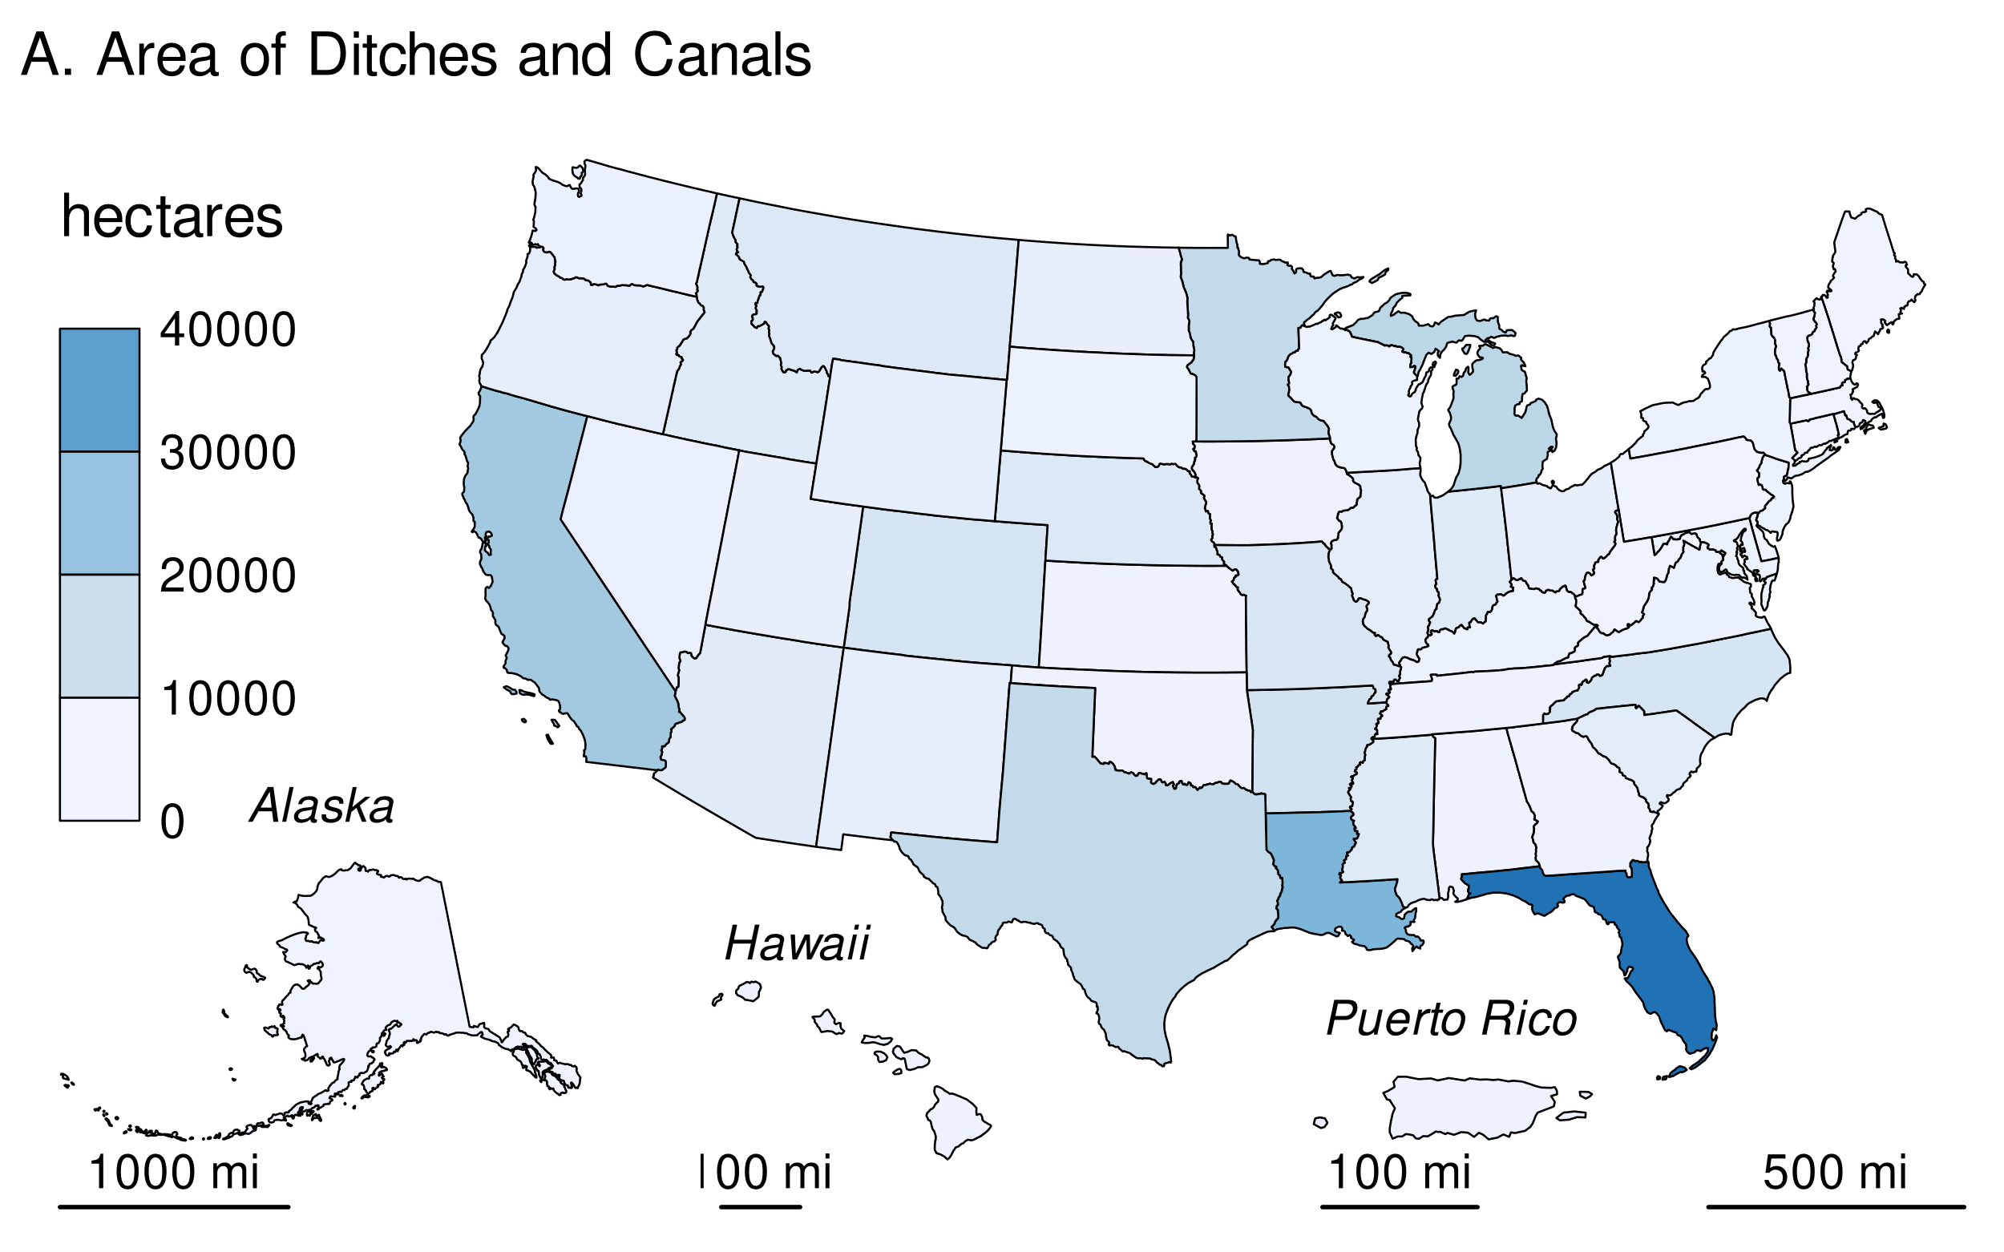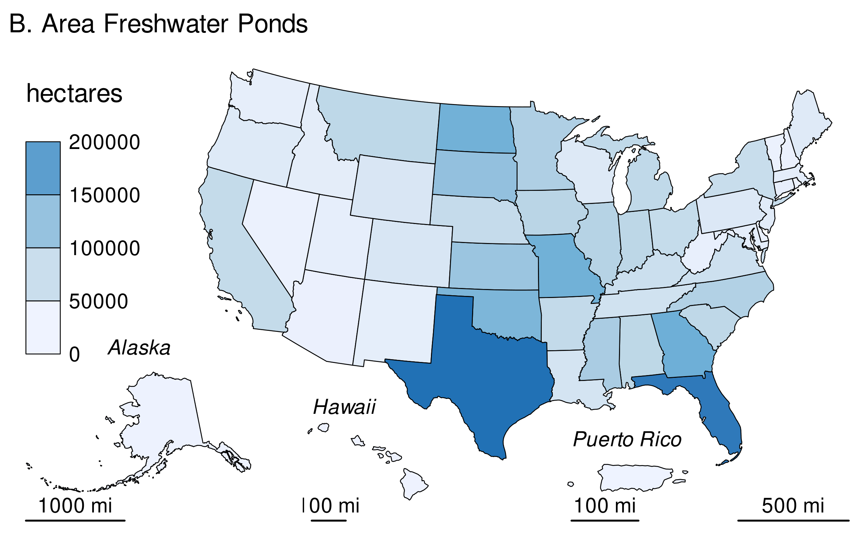

**Table 6‑94: State Totals of Surface Area in Flooded Land Remaining Flooded Land— Canals and Ditches (ha)**

|  |  |  |  |  |  |  |  |
| --- | --- | --- | --- | --- | --- | --- | --- |
| **State** | **1990** | **2005** | **2018** | **2019** | **2020** | **2021** | **2022** |
| Alabama | 228 | 228 | 228 | 228 | 228 | 228 | 228 |
| Alaska | 115 | 115 | 115 | 115 | 115 | 115 | 115 |
| Arizona | 3,536 | 3,536 | 3,536 | 3,536 | 3,536 | 3,536 | 3,536 |
| Arkansas | 7,349 | 7,349 | 7,349 | 7,349 | 7,349 | 7,349 | 7,349 |
| California | 16,725 | 16,725 | 16,725 | 16,725 | 16,725 | 16,725 | 16,725 |
| Colorado | 6,874 | 6,874 | 6,874 | 6,874 | 6,874 | 6,874 | 6,874 |
| Connecticut | 28 | 28 | 28 | 28 | 28 | 28 | 28 |
| Delaware | 130 | 130 | 130 | 130 | 130 | 130 | 130 |
| District of Columbia | 1 | 1 | 1 | 1 | 1 | 1 | 1 |
| Florida | 37,482 | 37,482 | 37,482 | 37,482 | 37,482 | 37,482 | 37,482 |
| Georgia | 352 | 352 | 352 | 352 | 352 | 352 | 352 |
| Hawaii | 538 | 538 | 538 | 538 | 538 | 538 | 538 |
| Idaho | 4,027 | 4,027 | 4,027 | 4,027 | 4,027 | 4,027 | 4,027 |
| Illinois | 2,489 | 2,489 | 2,489 | 2,489 | 2,489 | 2,489 | 2,489 |
| Indiana | 4,064 | 4,064 | 4,064 | 4,064 | 4,064 | 4,064 | 4,064 |
| Iowa | 867 | 867 | 867 | 867 | 867 | 867 | 867 |
| Kansas | 258 | 258 | 258 | 258 | 258 | 258 | 258 |
| Kentucky | 672 | 672 | 672 | 672 | 672 | 672 | 672 |
| Louisiana | 22,565 | 22,565 | 22,565 | 22,565 | 22,565 | 22,565 | 22,565 |
| Maine | 56 | 56 | 56 | 56 | 56 | 56 | 56 |
| Maryland | 967 | 967 | 967 | 967 | 967 | 967 | 967 |
| Massachusetts | 132 | 132 | 132 | 132 | 132 | 132 | 132 |
| Michigan | 12,897 | 12,897 | 12,897 | 12,897 | 12,897 | 12,897 | 12,897 |
| Minnesota | 11,235 | 11,235 | 11,235 | 11,235 | 11,235 | 11,235 | 11,235 |
| Mississippi | 3,936 | 3,936 | 3,936 | 3,936 | 3,936 | 3,936 | 3,936 |
| Missouri | 5,670 | 5,670 | 5,670 | 5,670 | 5,670 | 5,670 | 5,670 |
| Montana | 4,740 | 4,740 | 4,740 | 4,740 | 4,740 | 4,740 | 4,740 |
| Nebraska | 4,864 | 4,864 | 4,864 | 4,864 | 4,864 | 4,864 | 4,864 |
| Nevada | 1,587 | 1,587 | 1,587 | 1,587 | 1,587 | 1,587 | 1,587 |
| New Hampshire | 103 | 103 | 103 | 103 | 103 | 103 | 103 |
| New Jersey | 944 | 944 | 944 | 944 | 944 | 944 | 944 |
| New Mexico | 2,002 | 2,002 | 2,002 | 2,002 | 2,002 | 2,002 | 2,002 |
| New York | 925 | 925 | 925 | 925 | 925 | 925 | 925 |
| North Carolina | 6,321 | 6,321 | 6,321 | 6,321 | 6,321 | 6,321 | 6,321 |
| North Dakota | 1,819 | 1,819 | 1,819 | 1,819 | 1,819 | 1,819 | 1,819 |
| Ohio | 1,819 | 1,819 | 1,819 | 1,819 | 1,819 | 1,819 | 1,819 |
| Oklahoma | 278 | 278 | 278 | 278 | 278 | 278 | 278 |
| Oregon | 2,498 | 2,498 | 2,498 | 2,498 | 2,498 | 2,498 | 2,498 |
| Pennsylvania | 143 | 143 | 143 | 143 | 143 | 143 | 143 |
| Puerto Rico | 249 | 249 | 249 | 249 | 249 | 249 | 249 |
| Rhode Island | 1 | 1 | 1 | 1 | 1 | 1 | 1 |
| South Carolina | 3,226 | 3,226 | 3,226 | 3,226 | 3,226 | 3,226 | 3,226 |
| South Dakota | 703 | 703 | 703 | 703 | 703 | 703 | 703 |
| Tennessee | 442 | 442 | 442 | 442 | 442 | 442 | 442 |
| Texas | 11,152 | 11,152 | 11,152 | 11,152 | 11,152 | 11,152 | 11,152 |
| Utah | 1,875 | 1,875 | 1,875 | 1,875 | 1,875 | 1,875 | 1,875 |
| Vermont | 95 | 95 | 95 | 95 | 95 | 95 | 95 |
| Virginia | 1,306 | 1,306 | 1,306 | 1,306 | 1,306 | 1,306 | 1,306 |
| Washington | 1,125 | 1,125 | 1,125 | 1,125 | 1,125 | 1,125 | 1,125 |
| West Virginia | 28 | 28 | 28 | 28 | 28 | 28 | 28 |
| Wisconsin | 887 | 887 | 887 | 887 | 887 | 887 | 887 |
| Wyoming | 2,086 | 2,086 | 2,086 | 2,086 | 2,086 | 2,086 | 2,086 |
| **Total** | **194,412** | **194,412** | **194,412** | **194,412** | **194,412** | **194,412** | **194,412** |

**Table 6‑95: State Totals of Surface Area in Flooded Land Remaining Flooded Land— Freshwater Ponds (ha)**

|  |  |  |  |  |  |  |  |
| --- | --- | --- | --- | --- | --- | --- | --- |
| **State** | **1990** | **2005** | **2018** | **2019** | **2020** | **2021** | **2022** |
| Alabama | 57,034 | 57,342 | 57,355 | 57,355 | 57,355 | 57,355 | 57,355 |
| Alaska | 2,367 | 2,370 | 2,370 | 2,370 | 2,370 | 2,370 | 2,370 |
| Arizona | 5,199 | 5,236 | 5,249 | 5,249 | 5,253 | 5,253 | 5,253 |
| Arkansas | 50,880 | 51,211 | 51,211 | 51,211 | 51,211 | 51,211 | 51,211 |
| California | 50,219 | 50,426 | 50,499 | 50,504 | 50,511 | 50,513 | 50,519 |
| Colorado | 26,174 | 26,448 | 26,478 | 26,479 | 26,480 | 26,480 | 26,494 |
| Connecticut | 9,630 | 9,697 | 9,699 | 9,699 | 9,699 | 9,699 | 9,699 |
| Delaware | 4,717 | 4,721 | 4,721 | 4,721 | 4,721 | 4,721 | 4,721 |
| District of Columbia | 16 | 16 | 16 | 16 | 16 | 16 | 16 |
| Florida | 167,317 | 167,453 | 167,496 | 167,502 | 167,502 | 167,508 | 167,508 |
| Georgia | 113,254 | 114,898 | 114,969 | 114,972 | 114,972 | 114,972 | 114,972 |
| Hawaii | 1,580 | 1,592 | 1,595 | 1,595 | 1,595 | 1,595 | 1,595 |
| Idaho | 13,220 | 13,352 | 13,359 | 13,359 | 13,359 | 13,360 | 13,360 |
| Illinois | 63,516 | 64,044 | 64,144 | 64,149 | 64,159 | 64,160 | 64,169 |
| Indiana | 57,593 | 58,065 | 58,170 | 58,175 | 58,175 | 58,175 | 58,185 |
| Iowa | 57,450 | 59,612 | 60,745 | 60,929 | 61,051 | 61,147 | 61,168 |
| Kansas | 81,828 | 83,900 | 83,976 | 83,985 | 83,985 | 84,002 | 84,004 |
| Kentucky | 41,427 | 41,808 | 41,837 | 41,837 | 41,837 | 41,837 | 41,837 |
| Louisiana | 32,085 | 32,210 | 32,221 | 32,221 | 32,226 | 32,226 | 32,226 |
| Maine | 19,102 | 19,149 | 19,159 | 19,159 | 19,159 | 19,159 | 19,159 |
| Maryland | 12,569 | 12,739 | 12,810 | 12,810 | 12,812 | 12,815 | 12,818 |
| Massachusetts | 12,359 | 12,413 | 12,457 | 12,464 | 12,470 | 12,472 | 12,476 |
| Michigan | 54,525 | 54,672 | 54,701 | 54,701 | 54,709 | 54,709 | 54,709 |
| Minnesota | 68,801 | 69,082 | 69,173 | 69,176 | 69,202 | 69,210 | 69,220 |
| Mississippi | 72,832 | 73,209 | 73,336 | 73,343 | 73,363 | 73,375 | 73,383 |
| Missouri | 109,573 | 112,993 | 113,068 | 113,071 | 113,073 | 113,077 | 113,079 |
| Montana | 56,860 | 57,246 | 57,263 | 57,268 | 57,269 | 57,269 | 57,269 |
| Nebraska | 48,051 | 49,380 | 49,649 | 49,667 | 49,697 | 49,706 | 49,709 |
| Nevada | 4,452 | 4,455 | 4,508 | 4,509 | 4,512 | 4,512 | 4,515 |
| New Hampshire | 5,427 | 5,526 | 5,585 | 5,585 | 5,586 | 5,587 | 5,587 |
| New Jersey | 16,192 | 16,232 | 16,253 | 16,253 | 16,253 | 16,253 | 16,253 |
| New Mexico | 11,379 | 11,394 | 11,398 | 11,401 | 11,401 | 11,401 | 11,406 |
| New York | 45,224 | 45,485 | 45,590 | 45,592 | 45,592 | 45,598 | 45,598 |
| North Carolina | 66,205 | 66,661 | 66,744 | 66,744 | 66,747 | 66,750 | 66,751 |
| North Dakota | 112,310 | 112,384 | 112,469 | 112,475 | 112,485 | 112,489 | 112,492 |
| Ohio | 48,028 | 48,393 | 48,591 | 48,605 | 48,637 | 48,651 | 48,656 |
| Oklahoma | 103,243 | 105,224 | 105,288 | 105,304 | 105,318 | 105,324 | 105,333 |
| Oregon | 19,304 | 19,487 | 19,532 | 19,534 | 19,539 | 19,539 | 19,539 |
| Pennsylvania | 22,018 | 22,256 | 22,289 | 22,289 | 22,289 | 22,289 | 22,289 |
| Puerto Rico | 708 | 708 | 708 | 708 | 708 | 708 | 708 |
| Rhode Island | 2,204 | 2,213 | 2,220 | 2,220 | 2,220 | 2,220 | 2,220 |
| South Carolina | 55,794 | 56,456 | 56,673 | 56,682 | 56,686 | 56,686 | 56,686 |
| South Dakota | 90,237 | 90,447 | 90,504 | 90,515 | 90,516 | 90,521 | 90,521 |
| Tennessee | 35,927 | 36,307 | 36,332 | 36,337 | 36,343 | 36,344 | 36,344 |
| Texas | 172,580 | 175,497 | 175,569 | 175,574 | 175,575 | 175,575 | 175,575 |
| Utah | 10,703 | 10,764 | 10,772 | 10,772 | 10,773 | 10,773 | 10,773 |
| Vermont | 4,316 | 4,381 | 4,392 | 4,392 | 4,392 | 4,392 | 4,392 |
| Virginia | 39,938 | 39,996 | 40,000 | 40,000 | 40,000 | 40,000 | 40,000 |
| Washington | 10,943 | 11,081 | 11,119 | 11,119 | 11,122 | 11,123 | 11,123 |
| West Virginia | 8,027 | 8,156 | 8,166 | 8,166 | 8,166 | 8,166 | 8,166 |
| Wisconsin | 20,845 | 20,989 | 21,003 | 21,003 | 21,003 | 21,003 | 21,003 |
| Wyoming | 25,851 | 26,106 | 26,243 | 26,243 | 26,244 | 26,246 | 26,250 |
| **Total** | **2,222,030** | **2,245,881** | **2,249,672** | **2,250,007** | **2,250,337** | **2,250,540** | **2,250,662** |

**Uncertainty**

Uncertainty in estimates of CH4 emissions from other constructed waterbodies (ponds, canals/ditches) in flooded land remaining flooded land (Table 6‑96) are estimated using IPCC Approach 2 and include uncertainty in the default emission factors and the flooded land area inventory. Uncertainty in default emission factors is provided in the *2019 Refinement to the 2006 IPCC Guidelines* (IPCC 2019). Uncertainties in the spatial data include 1) uncertainty in area estimates from the NHD, NWI, and NW, and 2) uncertainty in the location of dams in the NID. Overall uncertainties in these spatial datasets are unknown, but uncertainty for remote sensing products is assumed to be ± 10 to 15 percent based on IPCC guidance (IPCC 2003). An uncertainty range of ± 15 percent for the flooded land area estimates is assumed and is based on expert judgment.

**Table 6‑96: Approach 2 Quantitative Uncertainty Estimates for CH4 Emissions from Other Constructed Waterbodies in Flooded Land Remaining Flooded Land**

|  |  |  |  |  |  |  |
| --- | --- | --- | --- | --- | --- | --- |
| **Source** | **Gas** | **2022 Emission Estimate** | **Uncertainty Range Relative to Emission Estimatea** | | | |
| **(MMT CO2 Eq.)** | **(MMT CO2 Eq.)** | | **(%)** | |
|  |  |  | **Lower Bound** | **Upper Bound** | **Lower Bound** | **Upper Bound** |
| Canals and ditches | CH4 | 2.3 | 2.1 | 2.4 | -5.1% | +7.0% |
| Freshwater pond | CH4 | 11.5 | 11.5 | 11.5 | -0.04% | +0.04% |
| **Total** | **CH4** | **13.8** | **13.7** | **13.9** | **-0.8%** | **+1.0%** |
| a Range of emission estimates predicted by Monte Carlo stochastic simulation for a 95 percent confidence interval. | | | | | | |

**QA/QC and Verification**

The National Hydrography Data (NHD) is managed by the USGS in collaboration many other federal, state, and local entities. Extensive QA/QC procedures are incorporated into the curation of the NHD. The National Inventory of Dams (NID) is maintained by the U.S. Army Corps of Engineers (USACE) in collaboration with the Federal Emergency Management Agency (FEMA) and state regulatory offices. USACE resolves duplicative and conflicting data from 68 data sources, which helps obtain the more complete, accurate, and updated NID.[13] The Navigable Waterways (NW) dataset is part of the U.S. Department of Transportation (USDOT)/Bureau of Transportation Statistics (BTS) National Transportation Atlas Database (NTAD). The NW is a comprehensive network database of the nation's navigable waterways updated on a continuing basis. U.S. Fish and Wildlife Service is the principal agency in charge of wetland mapping including the National Wetlands Inventory (NWI). Quality and consistency of the Wetlands Layer is supported by federal wetlands mapping and classification [standards](https://www.fws.gov/program/national-wetlands-inventory/data-standards), which were developed under the oversight of the Federal Geographic Data Committee (FGDC) with input by the [FGDC Wetlands Subcommittee](https://www.fgdc.gov/organization/working-groups-subcommittees/wsc/index_html). This dataset is part of the FGDC [Water-Inland Theme](https://www.geoplatform.gov/ngda/waterinland), which is co-chaired by the FWS and the U.S. Geological Survey. The EPA's Safe Drinking Water Information System (SDWIS) tracks information on drinking water contamination levels as required by the 1974 Safe Drinking Water Act and its 1986 and 1996 amendments.

General QA/QC procedures were applied to activity data, documentation, and emission calculations consistent with the U.S. Inventory QA/QC plan, which is in accordance with Vol. 1 Chapter 6 of *2006* *IPCC* *Guidelines* (see Annex 8 for more details). All calculations were executed independently in Excel and R. Ten percent of state and national totals were randomly selected for comparison between the two approaches to ensure there were no computational errors.

**Recalculations Discussion**

The EPA's SDWIS is a new data source used in the current (1990 through 2022) *Inventory*. The assumption is that any waterbody used as a public drinking water source is managed in some capacity—by flow and/or volume control. This data source added 54 features totaling 173 ha of other constructed waterbodies.

The National Inventory of Dams (NID) data are updated regularly. The version of NID used for the current (1990 through 2022) *Inventory* contains 47 new dams and updated values for “year of dam completion” for 975 dams relative to the previous (1990 through 2021) *Inventory* data. Similarly, the National Wetlands Inventory (NWI) is periodically updated. The NWI version used for the current *Inventory* has major updates for MS, ND, NM, and MT.

The net effect of these recalculations was an average annual decrease in CH4 emission estimates from other constructed waterbodies of 2.7 MMT CO2 Eq., or 17 percent, over the time series from 1990 to 2021 compared to the previous *Inventory*.

**Planned Improvements**

Default emission factors for canals/ditches were derived from a global dataset that include few measurements from U.S. systems. The EPA plans to conduct a literature survey to determine if sufficient data are available to derive a country-specific emission factor for the 1990 through 2024 *Inventory* submission.

Canal and ditch surface area included here may overlap with ditches and canals included in CH4 emission estimates for ditches draining inland organic soils (IPCC 2013, section 2.2.2.1). EPA plans to reconcile ditch/canal surface areas between the two managed land types (flooded land vs drained inland organic soils) in the next (i.e., 1990 through 2023) *Inventory*.

Features less than 8 ha in the NW that were not identified as Canal/Ditch were defined as freshwater ponds. Many of these features are lock chambers connected to an upstream reservoir. These systems likely have emission rates more similar to a reservoir than freshwater pond. In the next (1990 through 2023) *Inventory* these systems will be classified as reservoirs.

**Wetlands Remaining Wetlands: Flooded Land Remaining Flooded Land**

Abril, G., Gu´erin, F., Richard, S., Delmas, R., Galy-Lacaux, C., Gosse, P., et al. (2005) Carbon dioxide and methane emissions and the carbon budget of a 10-year old tropical reservoir (Petit Saut, French Guiana). Global Biogeochem. Cycles 19 (GB4007), 1–16. [https://doi.org/10.1029/2005GB002457](https://gcc02.safelinks.protection.outlook.com/?url=https%3A%2F%2Fdoi.org%2F10.1029%2F2005GB002457&data=05%7C01%7CBeaulieu.Jake%40epa.gov%7C546b63daf1784606eff908dadc5cfbc9%7C88b378b367484867acf976aacbeca6a7%7C0%7C0%7C638064589171865098%7CUnknown%7CTWFpbGZsb3d8eyJWIjoiMC4wLjAwMDAiLCJQIjoiV2luMzIiLCJBTiI6Ik1haWwiLCJXVCI6Mn0%3D%7C3000%7C%7C%7C&sdata=zmp1L5C5A%2FDNF6GQRg2h7gdfHaavESaoLwF0%2B%2FRiY2A%3D&reserved=0).

Barros, N., Cole, J.J., Tranvik, L.J., Prairie, Y.T., Bastviken, D., Huszar, V.L.M., et al. (2011) Carbon emission from hydroelectric reservoirs linked to reservoir age and latitude. Nat. Geosci. 4 (9), 593–596. [https://doi.org/10.1038/ngeo1211](https://gcc02.safelinks.protection.outlook.com/?url=https%3A%2F%2Fdoi.org%2F10.1038%2Fngeo1211&data=05%7C01%7CBeaulieu.Jake%40epa.gov%7C546b63daf1784606eff908dadc5cfbc9%7C88b378b367484867acf976aacbeca6a7%7C0%7C0%7C638064589171865098%7CUnknown%7CTWFpbGZsb3d8eyJWIjoiMC4wLjAwMDAiLCJQIjoiV2luMzIiLCJBTiI6Ik1haWwiLCJXVCI6Mn0%3D%7C3000%7C%7C%7C&sdata=LxKSLXeGCkP4yXVoN%2BZ01VkoIR3DDxUG4gXO3cCzb1E%3D&reserved=0).

Davis, D. W. (1973) Louisiana Canals and Their Influence on Wetland Development. Louisiana State University and Agricultural & Mechanical College. LSU Historical Dissertations and Theses. 2386., Louisiana State University.

IPCC (2019) 2019 Refinement to the 2006 Guidelines for National Greenhouse Gas Inventories. Wetlands, Chapter 7. Lovelock, C. E., Evans, C., Barros, N., Prairie, Y. T., Alm, J., Bastviken, D., Beaulieu, J. J., Garneau, M., Harby, A., Harrison, J. A., Pare, David, Raadal, Hanne Lerche, Sherman, B., Zhang, Chengyi, Ogle, S. M.IPCC (2013) *2013 Supplement to the 2006 IPCC Guidelines for National Greenhouse Gas Inventories: Wetlands.* Hiraishi, T., Krug, T., Tanabe, K., Srivastava, N., Baasansuren, J., Fukuda, M. and Troxler, T.G. (eds). In: IPCC, Switzerland.

IPCC (2006) *IPCC Guidelines for National Greenhouse Gas Inventories.* Prepared by the National Greenhouse Gas Inventories Programme, Eggleston H.S., Buendia L., Miwa K., Ngara T. and Tanabe K. (eds). IGES, Japan.

IPCC (2003) *Good Practice Guidance for Land Use, Land-Use Change and Forestry.* LUCF Sector Good Practice Guidance, Chapter 3. Penman, J., Gytarsky, M., Hiraishi, T., Krug, T., Kruger, D., Pipatti, R., Buendia, L., Miwa, K., Ngara, T., Tanabe, K. and Wagner, F. (eds). Institute of Global Environmental Strategies (IGES), on behalf of the Intergovernmental Panel on Climate Change (IPCC): Hayama, Japan.

Lehner B, Reidy Liermann C, Revenga C, Vorosmarty C, Fekete B, Crouzet P, Doll P, et al. (2011b) Global Reservoir and Dam Database, Version 1 (GRanDv1): Dams, Revision 01. In: Palisades, NY: NASA Socioeconomic Data and Applications Center (SEDAC).

Prairie, Y. T., et al. (2017) The GHG Reservoir Tool (G-res) User guide. UNESCO/IHA research project on the GHG status of freshwater reservoirs. Joint publication of the UNESCO Chair in Global Environmental Change and the International Hydropower Association: 38.

Teodoru, C.R., Bastien, J., Bonneville, M.C., Del Giorgio, P.a., Demarty, M., Garneau, M., et al., 2012. The net carbon footprint of a newly created boreal hydroelectric reservoir. Global Biogeochem. Cycles 26 (GB2016), 1–14. [https://doi.org/10.1029/](https://gcc02.safelinks.protection.outlook.com/?url=https%3A%2F%2Fdoi.org%2F10.1029%2F&data=05%7C01%7CBeaulieu.Jake%40epa.gov%7C546b63daf1784606eff908dadc5cfbc9%7C88b378b367484867acf976aacbeca6a7%7C0%7C0%7C638064589171865098%7CUnknown%7CTWFpbGZsb3d8eyJWIjoiMC4wLjAwMDAiLCJQIjoiV2luMzIiLCJBTiI6Ik1haWwiLCJXVCI6Mn0%3D%7C3000%7C%7C%7C&sdata=DB9GHwwVpFBMWQpPJnPsjGBMha7THoIj%2BISNYlEy4XM%3D&reserved=0)2011GB004187.

1. See <https://www.usgs.gov/core-science-systems/ngp/national-hydrography>.
2. See <https://nid.sec.usace.army.mil>.
3. See <https://www.fws.gov/program/national-wetlands-inventory/data-download>.
4. See <https://hifld-geoplatform.opendata.arcgis.com/maps/aaa3767c7d2b41f69e7528f99cf2fb76_0/about>.
5. See <https://www.epa.gov/enviro/sdwis-overview>. Not publicly available due to security concerns.
6. See <https://www.census.gov/geographies/mapping-files/time-series/geo/carto-boundary-file.html>.
7. See <https://www.epa.gov/air-research/research-emissions-us-reservoirs>.
8. See <https://www.usgs.gov/core-science-systems/ngp/national-hydrography>.
9. See <https://nid.sec.usace.army.mil>.
10. See <https://www.fws.gov/program/national-wetlands-inventory/data-download>.
11. See <https://hifld-geoplatform.opendata.arcgis.com/maps/aaa3767c7d2b41f69e7528f99cf2fb76_0/about>.
12. See <https://www.epa.gov/enviro/sdwis-overview>. Not publicly available due to security concerns.
13. See <https://www.epa.gov/national-aquatic-resource-surveys/national-lakes-assessment-2017-quality-assurance-project-plan>.